2023 VCE Systems Engineering external assessment report

General comments

In the 2023 VCE Systems Engineering examination, responses for each question needed to address all aspects of the question stem. Even when a statement in a response was true, if it did not answer the question, no marks could be given.

An area for improvement was understanding open and closed loop systems. The concept of a system was confused with that of a circuit and the idea of open and closed was inverted.

Correct units needed to be given in answers. For two- or three-mark questions, correct working needed to be shown and this was explicitly stated for each question.

Specific information

This report provides sample answers or an indication of what answers may have included. Unless otherwise stated, these are not intended to be exemplary or complete responses.

The statistics in this report may be subject to rounding, resulting in a total of more or less than 100 per cent.

Section A – Multiple-choice questions

Shading indicates the correct answer.

| Question | Correct answer | % A | % B | % C | % D | N/A | Comments |
| --- | --- | --- | --- | --- | --- | --- | --- |
| 1 | B | 7 | **65** | 13 | 14 | 1 | $\frac{40}{120}= \frac{1}{3}$ $\frac{1}{3} ×24 ×10=80 N$ |
| 2 | C | 23 | 2 | **73** | 1 | 0 | Brown = 1, Black = 0, multiplier = 100 000, Gold 5%.  Hence 1 MΩ at 5% |
| 3 | C | 6 | 23 | **11** | 60 | 0 | A voltmeter has a very high resistance in the order of MΩ. An ammeter has a resistance close to 0. Hence the ammeter reading is close to 0 and the voltmeter reading is close to 50 V. |
| 4 | B | 11 | **80** | 2 | 6 | 0 |  |
| 5 | A | **94** | 2 | 3 | 0 | 0 | There are 2 ropes connected to the moving mass so the mechanical advantage is 2. |
| 6 | C | 1 | 1 | **94** | 4 | 0 |  |
| 7 | B | 4 | **87** | 2 | 7 | 0 |  |
| 8 | B | 2 | **90** | 6 | 1 | 0 |  |
| 9 | D | 22 | 7 | 18 | **53** | 0 |  |
| 10 | C | 15 | 8 | **74** | 3 | 0 | The parallel resistors have a total resistance of 75Ω. $I= \frac{V}{R }= \frac{300}{75}=4 A$ |
| 11 | A | **98** | 0 | 0 | 1 | 0 |  |
| 12 | A | **23** | 1 | 64 | 12 | 0 | A trampoline uses extension springs not compression springs. |
| 13 | D | 4 | 5 | 2 | **88** | 1 | 70.0 × 2.5 = 175.0 N m |
| 14 | D | 2 | 5 | 6 | **87** | 0 |  |
| 15 | B | 7 | **64** | 24 | 5 | 0 |  |
| 16 | B | 23 | **39** | 17 | 19 | 2 | Capacitors in series add like resistors in parallel. C1 and C2 in series gives 22 nF. C3 needs to be 78 nF in order to get a total of 100 nF or 0.1 *µ*F |
| 17 | C | 13 | 2 | **79** | 5 | 0 |  |
| 18 | A | **52** | 35 | 8 | 4 | 1 | The voltage across R1 is 40 − 16 = 24 V.  Using I=V/R =  =2A |
| 19 | A | **31** | 39 | 26 | 4 | 0 | The voltage across R is 2.3 V. The current is 20 mA giving a resistance of 115 Ω |
| 20 | D | 8 | 25 | 31 | **36** | 1 |  |

Section B

Question 1a.

| Mark | 0 | 1 | 2 | 3 | Average |
| --- | --- | --- | --- | --- | --- |
| % | 33 | 11 | 7 | 49 | 1.7 |

Either W = F × d or Potential energy = m.g.h

W = F × d

F = 100 × 9.8 = 980 N

W = 980 x 25 =24 500 J.

Question 1b.

| Mark | 0 | 1 | 2 | Average |
| --- | --- | --- | --- | --- |
| % | 62 | 6 | 32 | 0.7 |

Some incorrect responses gave the power rating instead of the electrical energy used.

E = V × I × T = P × T = 500 × 60 = 30 000 J or 30 kJ.

Question 1c.

| Mark | 0 | 1 | 2 | Average |
| --- | --- | --- | --- | --- |
| % | 50 | 17 | 33 | 0.9 |

Both power and energy calculations gave the same correct answer.

Efficiency = $\frac{useful energy}{total energy}×100\%=\frac{24 500}{30 000} ×100\%$ = 82%.

Question 2a.

| Mark | 0 | 1 | 2 | 3 | 4 | Average |
| --- | --- | --- | --- | --- | --- | --- |
| % | 13 | 6 | 8 | 3 | 70 | 3.1 |

Two of the resistors are in parallel.

1/10 + 1/10 = 1/RP

RP = 5 Ω

Total resistance is RT = RP + R1 + R2 = 25 Ω.

Question 2b.

| Mark | 0 | 1 | Average |
| --- | --- | --- | --- |
| % | 33 | 67 | 0.7 |

I = V/R = 1 A

Units needed to be shown.

Question 2c.

| Mark | 0 | 1 | Average |
| --- | --- | --- | --- |
| % | 38 | 62 | 0.6 |

P = V × I = 25 W

Units needed to be shown.

Question 3a.

| Mark | 0 | 1 | 2 | Average |
| --- | --- | --- | --- | --- |
| % | 46 | 13 | 41 | 1.0 |

Transformer formula is

So

V1 = V2 = 60 V

Question 3b.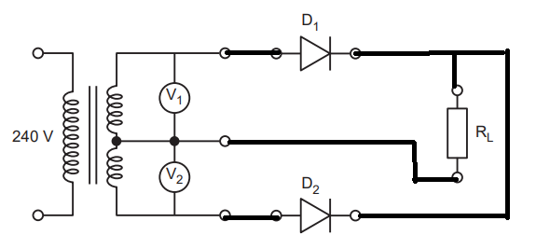

| Mark | 0 | 1 | 2 | 3 | Average |
| --- | --- | --- | --- | --- | --- |
| % | 47 | 36 | 6 | 11 | 0.8 |

Responses were awarded a mark for each of the following:

* the correct connections to the anodes.
* the correct connections to the cathodes.
* the connection from the centre tap to the resistor.

Any connections that cross but do not touch needed to be shown clearly. A bridge could be used.

Question 3c.

| Mark | 0 | 1 | Average |
| --- | --- | --- | --- |
| % | 55 | 45 | 0.5 |

A capacitor.

Question 3d.

| Mark | 0 | 1 | Average |
| --- | --- | --- | --- |
| % | 89 | 11 | 0.1 |

Across or parallel to the load resistor.

Question 4a.

| Mark | 0 | 1 | 2 | 3 | Average |
| --- | --- | --- | --- | --- | --- |
| % | 17 | 6 | 22 | 55 | 2.2 |

As the unit was not specified, the answer could have been given in watthours or joules.

Lighting: 20 × 6 = 120 W h or 432 000 J

Fridge: 100 × 2 = 200 W h or 720 000 J

Total: 120 + 100 = 320 W h = 0.32 kWh or 1 152 000 J.

Question 4b.

| Mark | 0 | 1 | Average |
| --- | --- | --- | --- |
| % | 43 | 57 | 0.6 |

Four panels.

Question 4c.

| Mark | 0 | 1 | 2 | 3 | Average |
| --- | --- | --- | --- | --- | --- |
| % | 44 | 22 | 6 | 28 | 1.2 |

320 W h are required each day so 960 W h are required for three days.

The battery provides 1200 W h. As 1200 is greater than 960, only one battery is required.

Question 5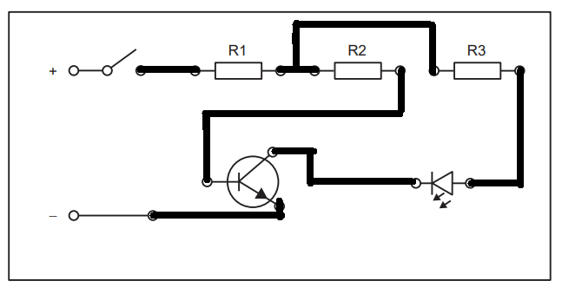

| Mark | 0 | 1 | 2 | 3 | 4 | 5 | 6 | Average |
| --- | --- | --- | --- | --- | --- | --- | --- | --- |
| % | 15 | 1 | 4 | 3 | 7 | 8 | 61 | 4.6 |

One mark was awarded for each completed track.

Question 6a.

| Mark | 0 | 1 | Average |
| --- | --- | --- | --- |
| % | 55 | 45 | 0.5 |

Examples of correct answers include automatic doors, cars, air conditioner and heaters.

The answer to Question 6b. was used to verify that the concept of open or closed loops was understood.

Question 6b.

| Mark | 0 | 1 | 2 | Average |
| --- | --- | --- | --- | --- |
| % | 60 | 10 | 30 | 0.7 |

These responses had to relate to Question 6a., clearly showing one open loop system and one closed loop system. For example, an air conditioner:

* Open loop system: The AC will release cool air regardless of whether the desired outcome of cooling the space is achieved.
* Closed loop system: The AC controls the temperature in the space by comparing it to nearby temperature by using a thermostat.

Question 6c.

| Mark | 0 | 1 | 2 | 3 | 4 | Average |
| --- | --- | --- | --- | --- | --- | --- |
| % | 59 | 5 | 18 | 3 | 16 | 1.1 |

The two advantages identified and **explained** in the context of the system identified in Question 6a.:

* Advantage 1 – reliability of the output
* Advantage 2 – accuracy of the output

Other factors were accepted within the context of the application identified, such as safety, convenience and comfort, as long as they were an advantage, not just a general comment.

Question 7a.

| Mark | 0 | 1 | Average |
| --- | --- | --- | --- |
| % | 57 | 43 | 0.5 |

$$Area=\frac{Force}{Pressure}=\frac{10}{2632}=3.8×{10}^{-3} m^{2}$$

Question 7b.

| Mark | 0 | 1 | Average |
| --- | --- | --- | --- |
| % | 53 | 47 | 0.5 |

$$F=P×A=26326×0.5=1316 N$$

Question 7c.

| Mark | 0 | 1 | Average |
| --- | --- | --- | --- |
| % | 52 | 48 | 0.5 |

The difference in diameter of the cylinders produces mechanical advantage.

Question 7d.

| Mark | 0 | 1 | 2 | 3 | 4 | Average |
| --- | --- | --- | --- | --- | --- | --- |
| % | 38 | 9 | 6 | 3 | 44 | 2.1 |

F2 = m2 × g = 2800 × 9.8 = 27 440 N

P1 = P2

.

Question 8a.

| Mark | 0 | 1 | Average |
| --- | --- | --- | --- |
| % | 32 | 68 | 0.7 |

To produce electric energy/power.

Question 8b.

| Mark | 0 | 1 | Average |
| --- | --- | --- | --- |
| % | 49 | 51 | 0.5 |

A backup generator.

Question 8c.

| Mark | 0 | 1 | 2 | 3 | 4 | 5 | 6 | Average |
| --- | --- | --- | --- | --- | --- | --- | --- | --- |
| % | 37 | 12 | 12 | 10 | 10 | 9 | 10 | 2.1 |

|  | Part | Function |
| --- | --- | --- |
| X | Coil | The rotating coil in a magnetic field produces electric current. |
| Y | Slip rings | Slip rings are electrical connectors in the rotor for transferring power to and from it. |
| Z | Brush | Points of electrical contact between the rotor and the external. circuit. |

Question 9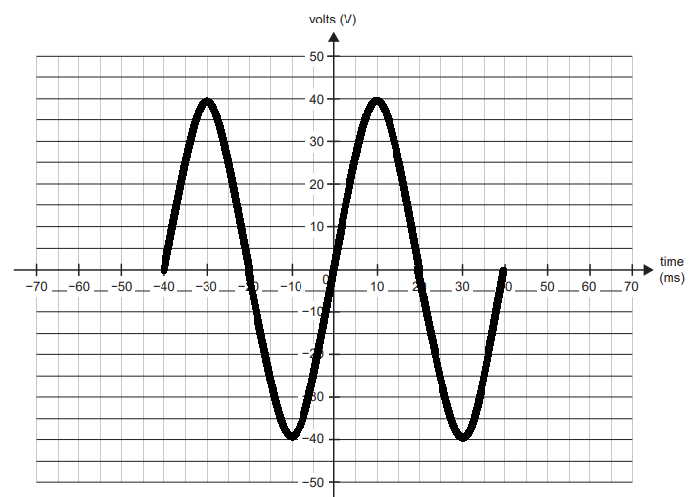

| Mark | 0 | 1 | 2 | Average |
| --- | --- | --- | --- | --- |
| % | 30 | 39 | 30 | 1.0 |

Time period: T = 1/f = 1/25 = 0.04s = 40 ms. Amplitude = 40 V.

Two complete periods were required. The starting point was not critical.

Question 10

| Mark | 0 | 1 | 2 | 3 | Average |
| --- | --- | --- | --- | --- | --- |
| % | 39 | 40 | 17 | 4 | 0.9 |

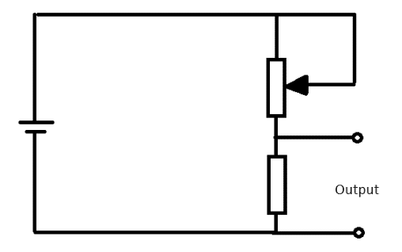 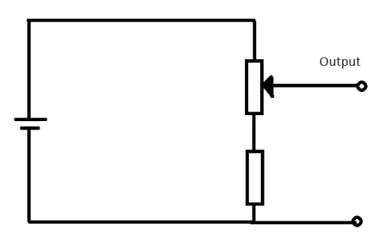

Two possible answers are given above. Some students gave an output from 0 to 2.5 volts, others used a variable resistor instead of a potentiometer.

Question 11a.

| Mark | 0 | 1 | 2 | 3 | 4 | Average |
| --- | --- | --- | --- | --- | --- | --- |
| % | 39 | 32 | 13 | 10 | 6 | 1.2 |

Suggested solution:

For an electric car: useful energy per volume = 2.6 MJ/L × 50% = 1.3 MJ/L

For biodiesel car: Useful energy per volume = 42.2 MJ/L × 33% = 13.9 MJ/L.

The stem of the question asked for the use of calculations. The efficiency multiplied by the energy density or the specific energy was required. A comparison of these two calculations shows that electric vehicles require a lot more space than biodiesel for the same range.

Question 11b.

| Mark | 0 | 1 | 2 | Average |
| --- | --- | --- | --- | --- |
| % | 46 | 27 | 27 | 0.8 |

The infrastructure for petrol vehicles includes tanks and petrol stations for storage of petrol and petrol tankers for transportation.

The required infrastructure for electric vehicles includes increasing the number of charging stations and providing energy to remote charging stations.

Since electric vehicles have less range than petrol vehicles, they need more charging stations.

Question 12

| Mark | 0 | 1 | 2 | 3 | 4 | Average |
| --- | --- | --- | --- | --- | --- | --- |
| % | 34 | 9 | 20 | 25 | 12 | 1.8 |

One possible scenario:

* A remote-controlled boat has a tube that can be lowered into the water.
* A stepper motor is used to lower the tube to the correct depth of 500 mm.
* A pump connected to the tube extracts a sample of water from the desired depth.
* To measure the cloudiness, the sample of water is placed between a light source (light emitting diode, LED) and a phototransistor (photodiode, light-dependent resistors; LDR) circuit that uses a microcontroller programmed to determine the cloudiness level.

Question 13a.

| Mark | 0 | 1 | Average |
| --- | --- | --- | --- |
| % | 79 | 21 | 0.2 |

As the teeth are further apart, the rate of steering increases.

Question 13b.

| Mark | 0 | 1 | 2 | 3 | Average |
| --- | --- | --- | --- | --- | --- |
| % | 42 | 22 | 10 | 27 | 1.2 |

When D rotates once, C1 and C2 rotate once. When C2 rotates once, B rotates 150/120 = 1.25 times.

When B rotates once, A rotates  = 5 times.

So, when D rotates once, A rotates 1.25 × 5 = 6.25 times, so for D to rotate four turns, A rotates 4 × 6.25 = 25 times.

Alternatively, B can be treated as an idler gear.

Question 14a.

| Mark | 0 | 1 | 2 | Average |
| --- | --- | --- | --- | --- |
| % | 9 | 29 | 62 | 1.6 |

Both a factor and an explanation needed to be given. Two examples are:

* Environmental factor 1 – Wind turbines can be seen as an intrusion on the visual landscape. This may affect tourism and property prices.
* Environmental factor 2 – Wind turbines may have impacts on birds and bats. It may affect nesting site, migration routes. Death rates may impact endangered status.

Question 14b.

| Mark | 0 | 1 | 2 | 3 | 4 | Average |
| --- | --- | --- | --- | --- | --- | --- |
| % | 16 | 10 | 26 | 19 | 29 | 2.4 |

When evaluating, advantages and disadvantages along with detail must be given. In their response students needed to make a judgement using the provided information and/or their own knowledge.

Some possible arguments:

* Both wind farms and solar farms are sustainable sources of energy.
* Wind farms can have mixed use of land with agriculture. Relatively small footprint allows sunlight penetration for fodder growth and grazing.
* Wind farms are typically more expensive to install, due to increased structural needs. These include substantial concrete footprint, towers, blades and remote location. They require regular maintenance due to moving parts.
* Solar farms are cheaper to install and have no noise impact on the environment. A disadvantage is that at the end of their life, solar panels are put in landfill.
* Overall, the preference for either solar or wind electrical generation depends on geographical location. In a high wind area, wind generation is preferred, while solar is better suited for high sun areas.